
Your Ad Account Doesn't Need Your Help
2026-09-13 · Growth Marketing & Branding · CAROUSEL (7 slides)
Recommended: Overridden from the scouted STATIC guess to a CAROUSEL. The idea needs a breakdown, not one punch: set up the common belief, reveal the mechanism, back it with a real Meta stat, show the cost of interrupting it, then land a concrete fix. Seven short beats land better as a sequence than as a single static claim.

The Anchor
Subject: Meta Ads Manager's budget pacing system (Standard Pacing vs Accelerated / no_pacing)
Real fact: Meta's own Marketing API documentation states that with Standard Pacing, the default on every ad set, Meta enters the ad into every relevant auction and adjusts the bid across the whole day to produce smooth, optimal delivery, instead of spending early or evenly. Meta's Business Help Center confirms the payoff of that patience in writing: On days when better advertising opportunities are available, Meta may spend up to 75 percent over your daily budget. Accelerated pacing (no_pacing) does the opposite: it removes the pacing adjustment and bids at full strength in every auction until the budget is gone, sometimes before the day ends. Verified directly against Meta's current official documentation on 2026-09-13.
Time peg: evergreen mechanism, corroborated against Meta's live official documentation
Source 1: https://www.facebook.com/business/help/190490051321426
Source 2: https://developers.facebook.com/documentation/ads-commerce/marketing-api/bidding/overview/pacing-and-scheduling
Source 3: https://roaspig.com/blog/budget-pacing-strategy-meta

The Big Idea
Meta's algorithm is built to hold budget back on purpose, betting a cheaper conversion shows up later in the day, so an advertiser who manually pauses at 3pm to save budget for tonight is just badly reenacting a job Standard Pacing already does by default.

Audience Takeaway
Stop manually pausing and resuming campaigns to protect budget for peak hours. If a window truly matters, set the schedule once in the ad set. Interrupting Standard Pacing does not add discipline, it deletes the day's auction learning and forces the account to relearn from zero.

Headline (the only text on the hero image)
EN: Your ad account doesn't need your *help*.
ES: Tu cuenta de anuncios no necesita tu *ayuda*.
PT: Sua conta de anuncios nao precisa da sua *ajuda*.
Headline color: #D50057 magenta (default) (off-brand allowed; chosen to stop the scroll)

Carousel Slides
Slide | EN | ES | PT
1 | Your ad account doesn't need your *help*. Every time you pause it at 3pm, you undo the one thing it already does right. | Tu cuenta de anuncios no necesita tu *ayuda*. Cada vez que la pausas a las 3pm, deshaces lo unico que ya hace bien. | Sua conta de anuncios nao precisa da sua *ajuda*. Toda vez que voce pausa ela as 15h, desfaz a unica coisa que ela ja faz certo.
2 | Plenty of media buyers pause campaigns mid afternoon on purpose. The logic sounds disciplined: stop the spend now, protect what is left for prime time tonight. | Muchos media buyers pausan sus campanas a media tarde a proposito. La logica suena disciplinada: frenar el gasto ahora para proteger lo que queda para el horario estelar de la noche. | Muitos gestores de trafego pausam campanhas no meio da tarde de proposito. A logica parece disciplinada: travar o gasto agora para guardar o que sobra pro horario nobre da noite.
3 | Meta already built that instinct into Standard Pacing, the default on every ad set. The system enters every relevant auction and adjusts its own bid across the day, spreading spend on purpose instead of burning it early. | Meta ya integro ese instinto en el Standard Pacing, la opcion predeterminada de cada conjunto de anuncios. El sistema entra en cada subasta relevante y ajusta su propia puja a lo largo del dia, repartiendo el gasto a proposito en vez de quemarlo temprano. | A Meta ja embutiu esse instinto no Standard Pacing, o padrao de toda conta de anuncios. O sistema entra em cada leilao relevante e ajusta o proprio lance ao longo do dia, distribuindo o gasto de proposito em vez de queimar tudo cedo.
4  [75%] | Meta's own Business Help Center says it in writing: on a day when a better opportunity shows up, the system may spend up to 75 percent over the daily budget to catch it. The reserve a 3pm pause is meant to protect is already part of how the system works. | El propio Centro de Ayuda para Empresas de Meta lo dice por escrito: en un dia con una mejor oportunidad, el sistema puede gastar hasta un 75 por ciento mas del presupuesto diario para aprovecharla. La reserva que una pausa a las 3pm busca proteger ya es parte de como funciona el sistema. | O proprio Central de Ajuda para Empresas da Meta afirma por escrito: num dia com uma oportunidade melhor, o sistema pode gastar ate 75 por cento a mais do orcamento diario pra aproveitar. A reserva que uma pausa as 15h tenta proteger ja faz parte de como o sistema funciona.
5 | The opposite setting, accelerated pacing, shows what abandoning that patience looks like: full bid in every auction until the budget is gone, sometimes before the day even ends. A manual pause pushes a campaign toward that same rush, forcing it to relearn the day's auctions from zero once it resumes. | El ajuste opuesto, el pacing acelerado, muestra lo que pasa al abandonar esa paciencia: puja maxima en cada subasta hasta que el presupuesto se acaba, a veces antes de que termine el dia. Una pausa manual empuja a la campana hacia esa misma prisa, obligandola a reaprender las subastas del dia desde cero al reanudarse. | A configuracao oposta, o pacing acelerado, mostra o que acontece ao abandonar essa paciencia: lance maximo em cada leilao ate o orcamento acabar, as vezes antes do dia terminar. Uma pausa manual empurra a campanha pra essa mesma pressa, forcando ela a reaprender os leiloes do dia do zero quando volta a rodar.
6 | The fix is not more discipline at 3pm. It is a schedule set once in the ad set, so the system keeps the memory it needs to actually find the cheap hour on its own. | La solucion no es mas disciplina a las 3pm. Es un horario configurado una sola vez en el conjunto de anuncios, para que el sistema conserve la memoria que necesita para encontrar la hora barata por su cuenta. | A solucao nao e mais disciplina as 15h. E um horario configurado uma unica vez no conjunto de anuncios, pra que o sistema mantenha a memoria que precisa pra achar a hora barata sozinho.
7 | Save this. Send it to a friend who runs ads. | Guarda esto. Enviaselo a un amigo que hace anuncios. | Salva isso. Manda pra um amigo que faz anuncios.

Caption (EN)
Your ad account already knows how to wait for the cheap hour. Stop taking that job away from it.
A lot of performance marketers pause campaigns around 3pm on principle, protecting whatever budget is left for the evening rush. It feels like restraint.
Meta's own Business Help Center states that on a day when a better opportunity shows up, the system may spend up to 75 percent over the daily budget to catch it. That flexibility exists because Standard Pacing, the default on every ad set, already enters every relevant auction and adjusts its bid across the whole day instead of spending it all early.
A manual pause does not add discipline. It interrupts a system built for exactly this, and forces it to relearn the day's auctions from zero the moment it resumes.
Save this. Send it to a founder who still babysits campaigns by hand.
#RarityAgency #MetaAds #GrowthMarketing

Caption (ES)
Tu cuenta de anuncios ya sabe esperar la hora barata. Dejale hacer ese trabajo.
Muchos performance marketers pausan sus campanas cerca de las 3pm por principio, para proteger lo que queda del presupuesto para el pico de la noche. Se siente como disciplina.
El propio Centro de Ayuda para Empresas de Meta afirma que en un dia con una mejor oportunidad, el sistema puede gastar hasta un 75 por ciento mas del presupuesto diario para aprovecharla. Esa flexibilidad existe porque el Standard Pacing, la opcion predeterminada en cada conjunto de anuncios, ya entra en cada subasta relevante y ajusta su puja a lo largo de todo el dia en vez de gastarlo todo temprano.
Una pausa manual no agrega disciplina. Interrumpe un sistema construido justo para esto, y lo obliga a reaprender las subastas del dia desde cero en cuanto se reanuda.
Guarda esto. Enviaselo a un fundador que todavia cuida sus campanas a mano.
#RarityAgency #MetaAds #Performance

Caption (PT)
Sua conta de anuncios ja sabe esperar a hora barata. Para de tirar esse trabalho dela.
Muitos gestores de trafego pausam campanhas por volta das 15h por principio, pra guardar o que sobrou do orcamento pro pico da noite. Parece disciplina.
O proprio Central de Ajuda para Empresas da Meta afirma que, num dia com uma oportunidade melhor, o sistema pode gastar ate 75 por cento a mais do orcamento diario pra aproveitar. Essa flexibilidade existe porque o Standard Pacing, o padrao em toda conta de anuncios, ja entra em cada leilao relevante e ajusta o lance ao longo do dia inteiro em vez de gastar tudo cedo.
Uma pausa manual nao adiciona disciplina. Ela interrompe um sistema feito exatamente pra isso, e forca ele a reaprender os leiloes do dia do zero assim que volta a rodar.
Salva isso. Manda pra um fundador que ainda fica de baba em campanha.
#RarityAgency #MetaAds #TrafegoPago

Images (sourced from the web)
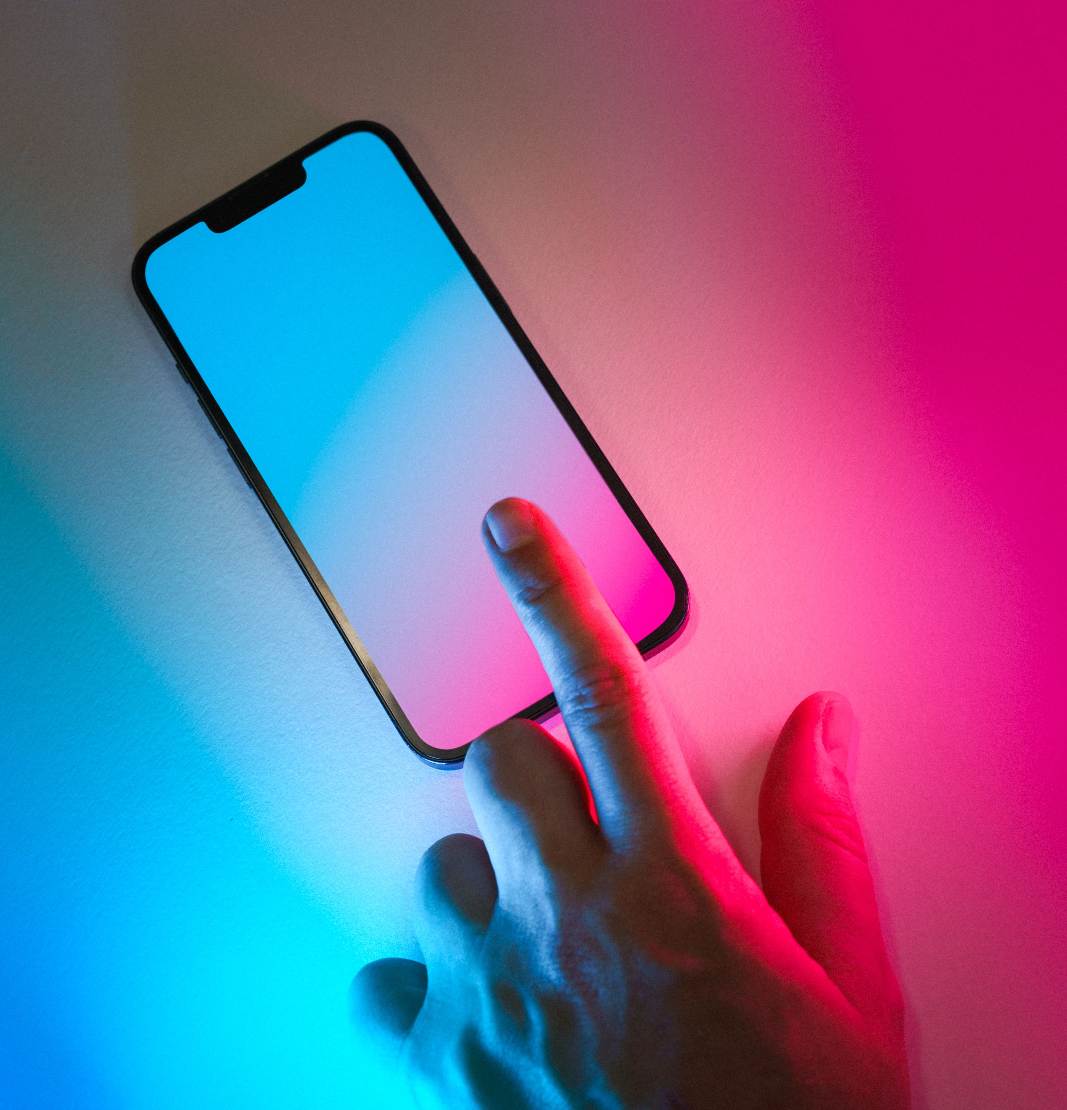
Slide 1 (Hook) - a finger hovers just above a smartphone screen glowing in a vivid magenta to cyan gradient, extreme close up, full frame, metaphor for pausing the ad. Gate0: viewed direct, 3000x3119px, URL verified, not a banned trope, used on 2 slides with visibly different crops, Pexels License traced to source page. Scores: subject match (metaphor case) 8, five unrelated posts test 8, charge 10, currency 10, legibility 9, set distinction 9. Beat runner up: a flat white product mockup shot of a hand pointing at a blank phone screen (pexels 24503743) was viewed and rejected for reading as a posed catalog shot with no drama and no legible zones.: https://images.pexels.com/photos/27788817/pexels-photo-27788817.jpeg
Source: https://www.pexels.com/photo/index-finger-on-smartphone-neon-colours-mobile-device-27788817/ Author: Jakub Zerdzicki License: Pexels License (free for commercial and non commercial use)
Slide 2 (Tension) - reuse of Slide 1's photo, cropped tighter into just the glowing gradient screen with the finger cropped out of frame, a visibly different composition from Slide 1. Gate0: reuse permitted (2 of 2 max), same Pexels License traced. Scores: subject match (metaphor) 7, five unrelated posts test 7, charge 9, currency 10, legibility 9.: https://images.pexels.com/photos/27788817/pexels-photo-27788817.jpeg
Source: https://www.pexels.com/photo/index-finger-on-smartphone-neon-colours-mobile-device-27788817/ Author: Jakub Zerdzicki License: Pexels License (free for commercial and non commercial use)
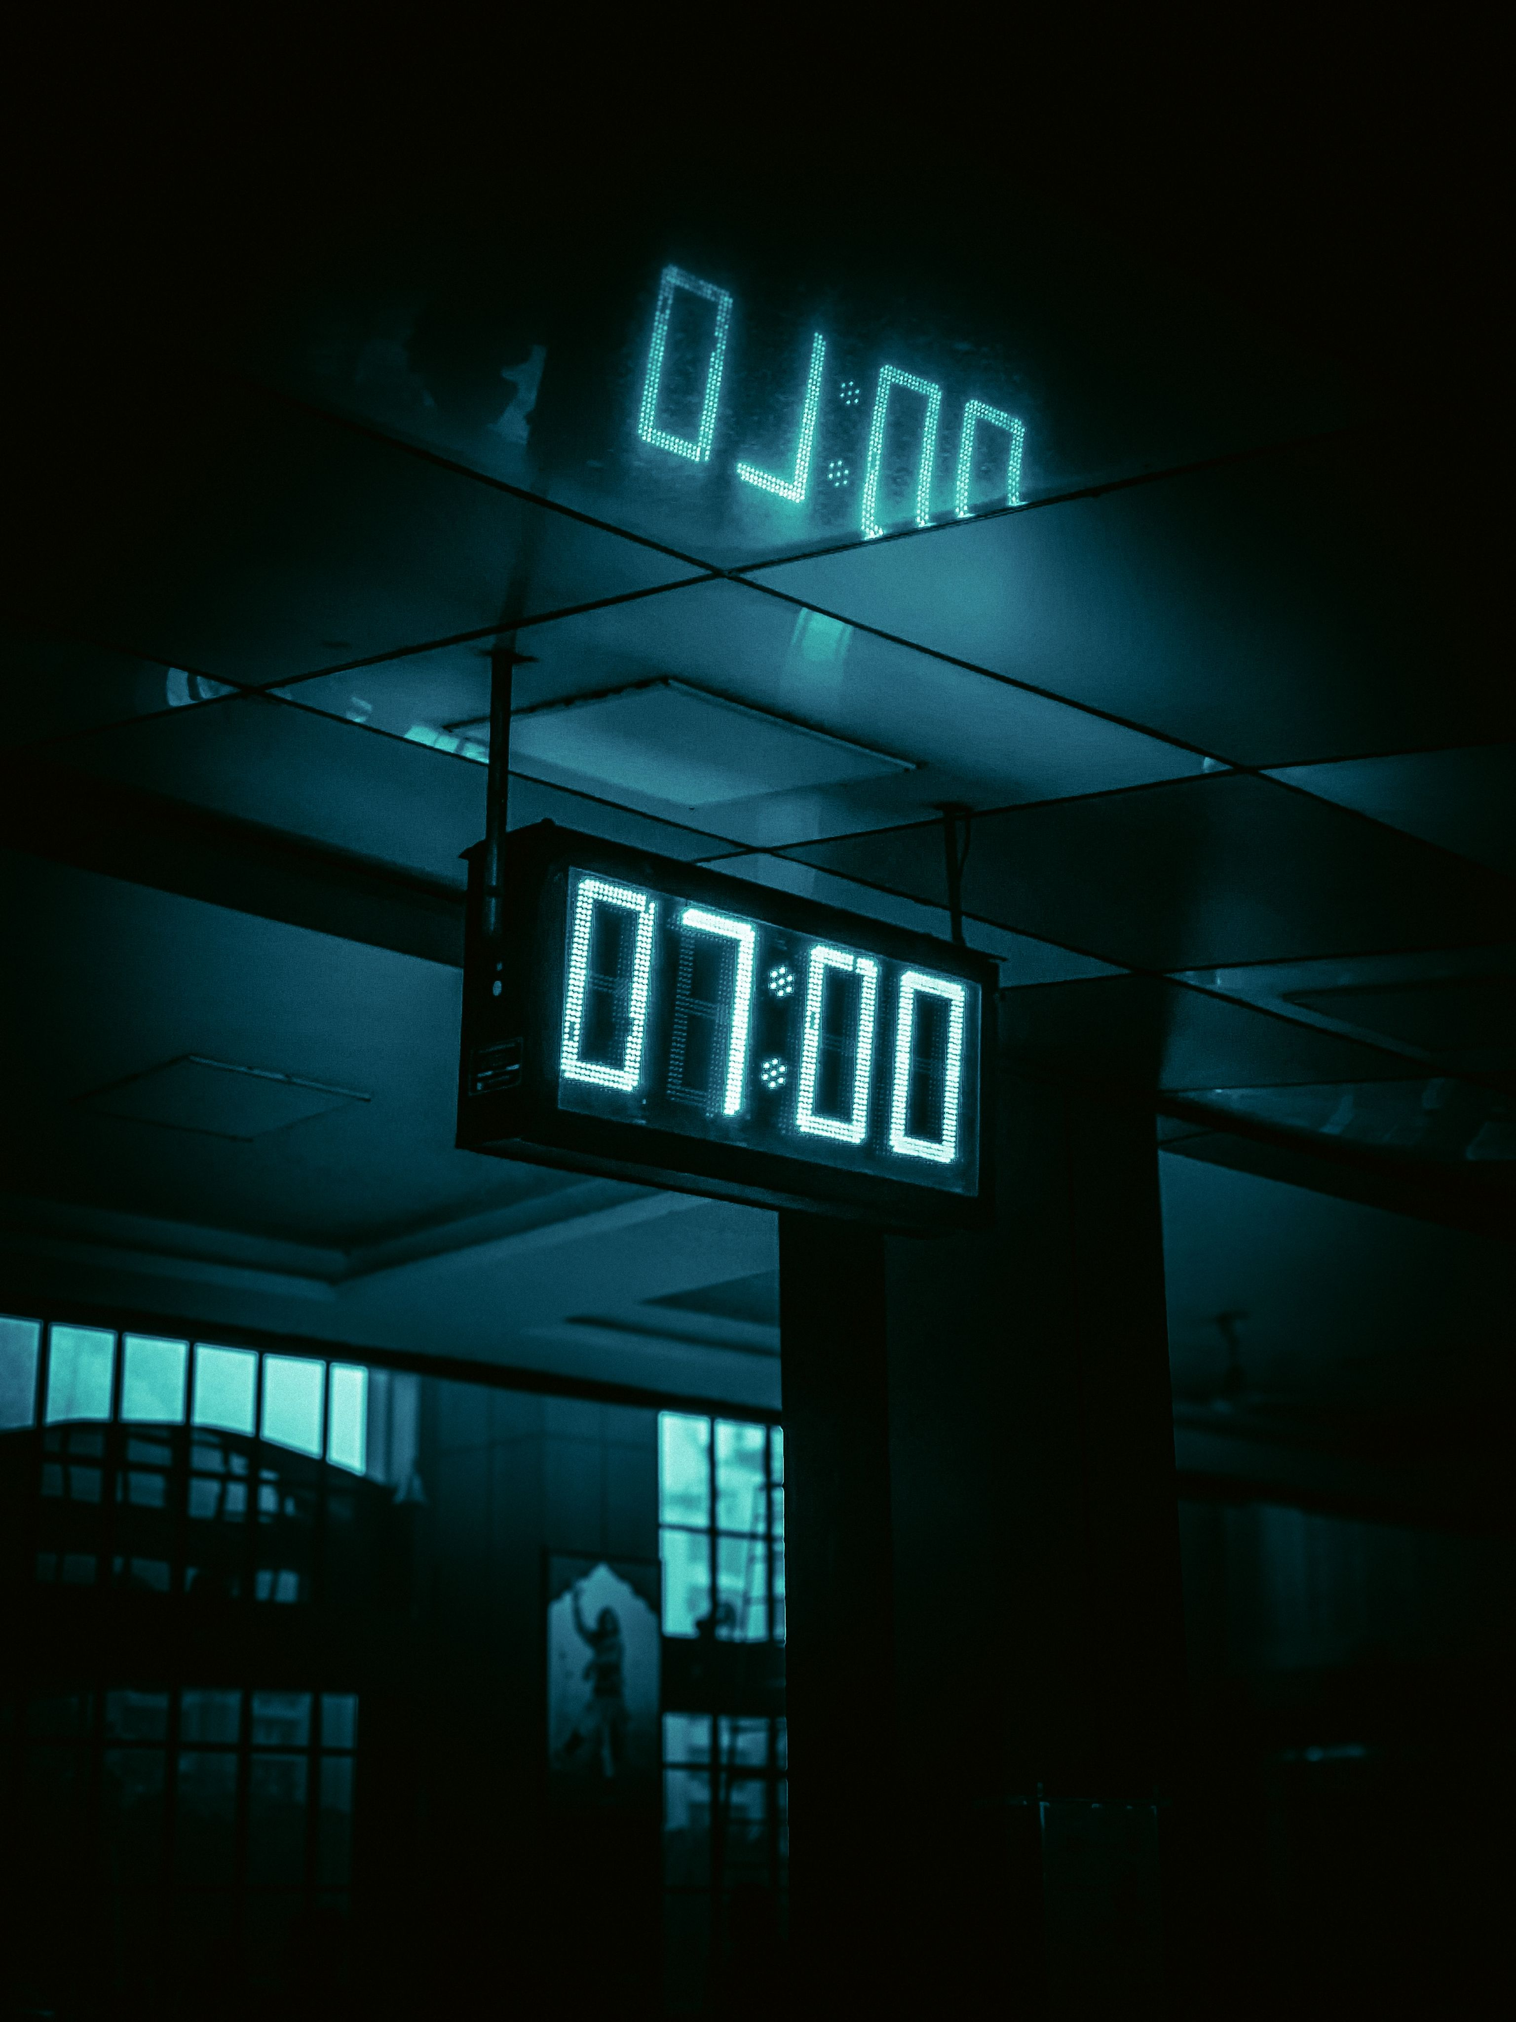
Slide 3 (Mechanism) - a large digital LED clock reading 07:00 in glowing teal, mounted in a dark, empty interior, with a soft reflection of the same digits visible on the ceiling above. Gate0: viewed direct, 3072x4096px, URL verified, not a banned trope, used on 2 slides with visibly different crops, Pexels License traced. Scores: subject match (metaphor for time of day pacing) 9, five unrelated posts test 7, charge 9, currency 9, legibility 9, set distinction 9.: https://images.pexels.com/photos/30223389/pexels-photo-30223389.jpeg
Source: https://www.pexels.com/photo/digital-clock-at-7-00-reflecting-in-a-modern-building-30223389/ Author: Tanay Agrawal License: Pexels License (free for commercial and non commercial use)
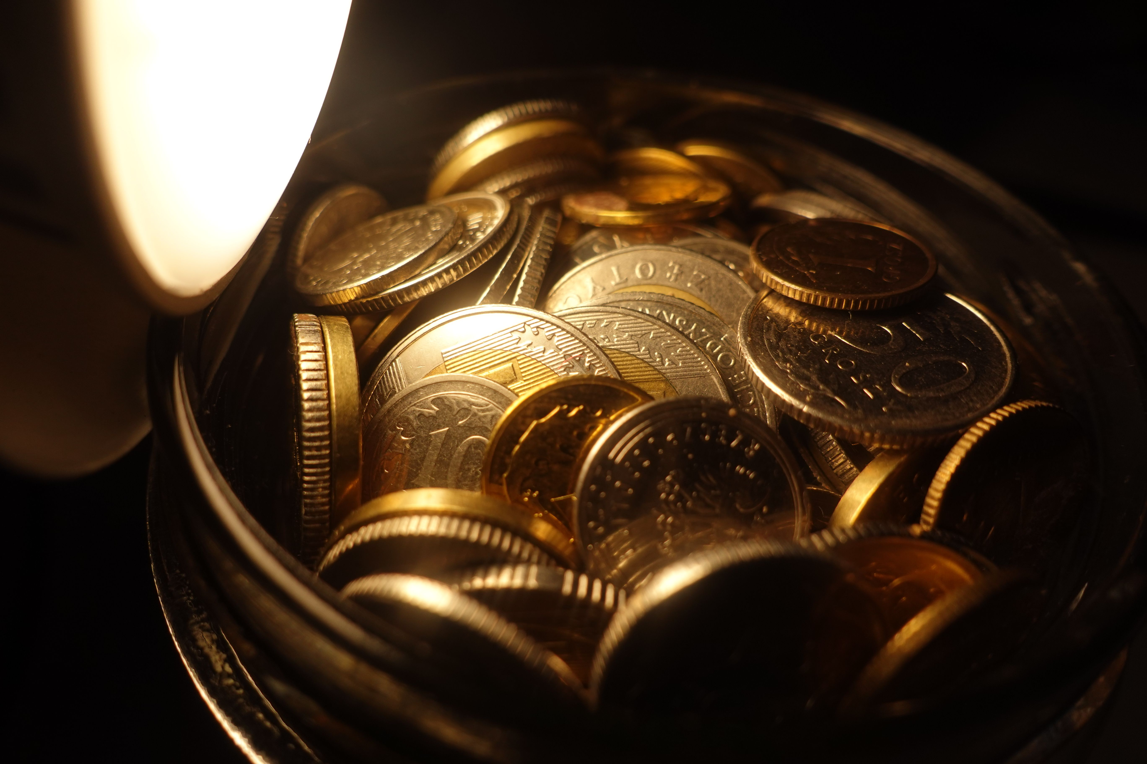
Slide 4 (Proof, 75 percent) - a bowl of assorted coins shot close and low, lit by a single bright warm point light against an otherwise black frame. Gate0: viewed direct, 5472x3648px, URL verified, not a banned trope, used once, Pexels License traced. Scores: subject match (metaphor for reserved budget) 8, five unrelated posts test 8, charge 8, currency 8, legibility 10, set distinction 9. Beat runner up: a close up of fanned US 100 dollar bills (pexels 32553496) was viewed and rejected, it reads as interchangeable generic wealth stock; the spotlit coin bowl is more distinct and gives cleaner negative space for the 75% numeral.: https://images.pexels.com/photos/18501298/pexels-photo-18501298.jpeg
Source: https://www.pexels.com/photo/close-up-of-coins-18501298/ Author: Lukasz Pajzert License: Pexels License (free for commercial and non commercial use)

Slide 5 (Cost) - extreme close up of a car speedometer, red needle swung hard toward the top of the dial near 80, dashboard warning lights lit red, everything else dark. Gate0: viewed direct, 7008x4672px, URL verified, not a banned trope, used once, Pexels License traced. Scores: subject match (metaphor for accelerated pacing) 9, five unrelated posts test 8, charge 10, currency 9, legibility 8, set distinction 9.: https://images.pexels.com/photos/19316774/pexels-photo-19316774.jpeg
Source: https://www.pexels.com/photo/close-up-of-honda-accord-speedometer-19316774/ Author: Luke Miller License: Pexels License (free for commercial and non commercial use)
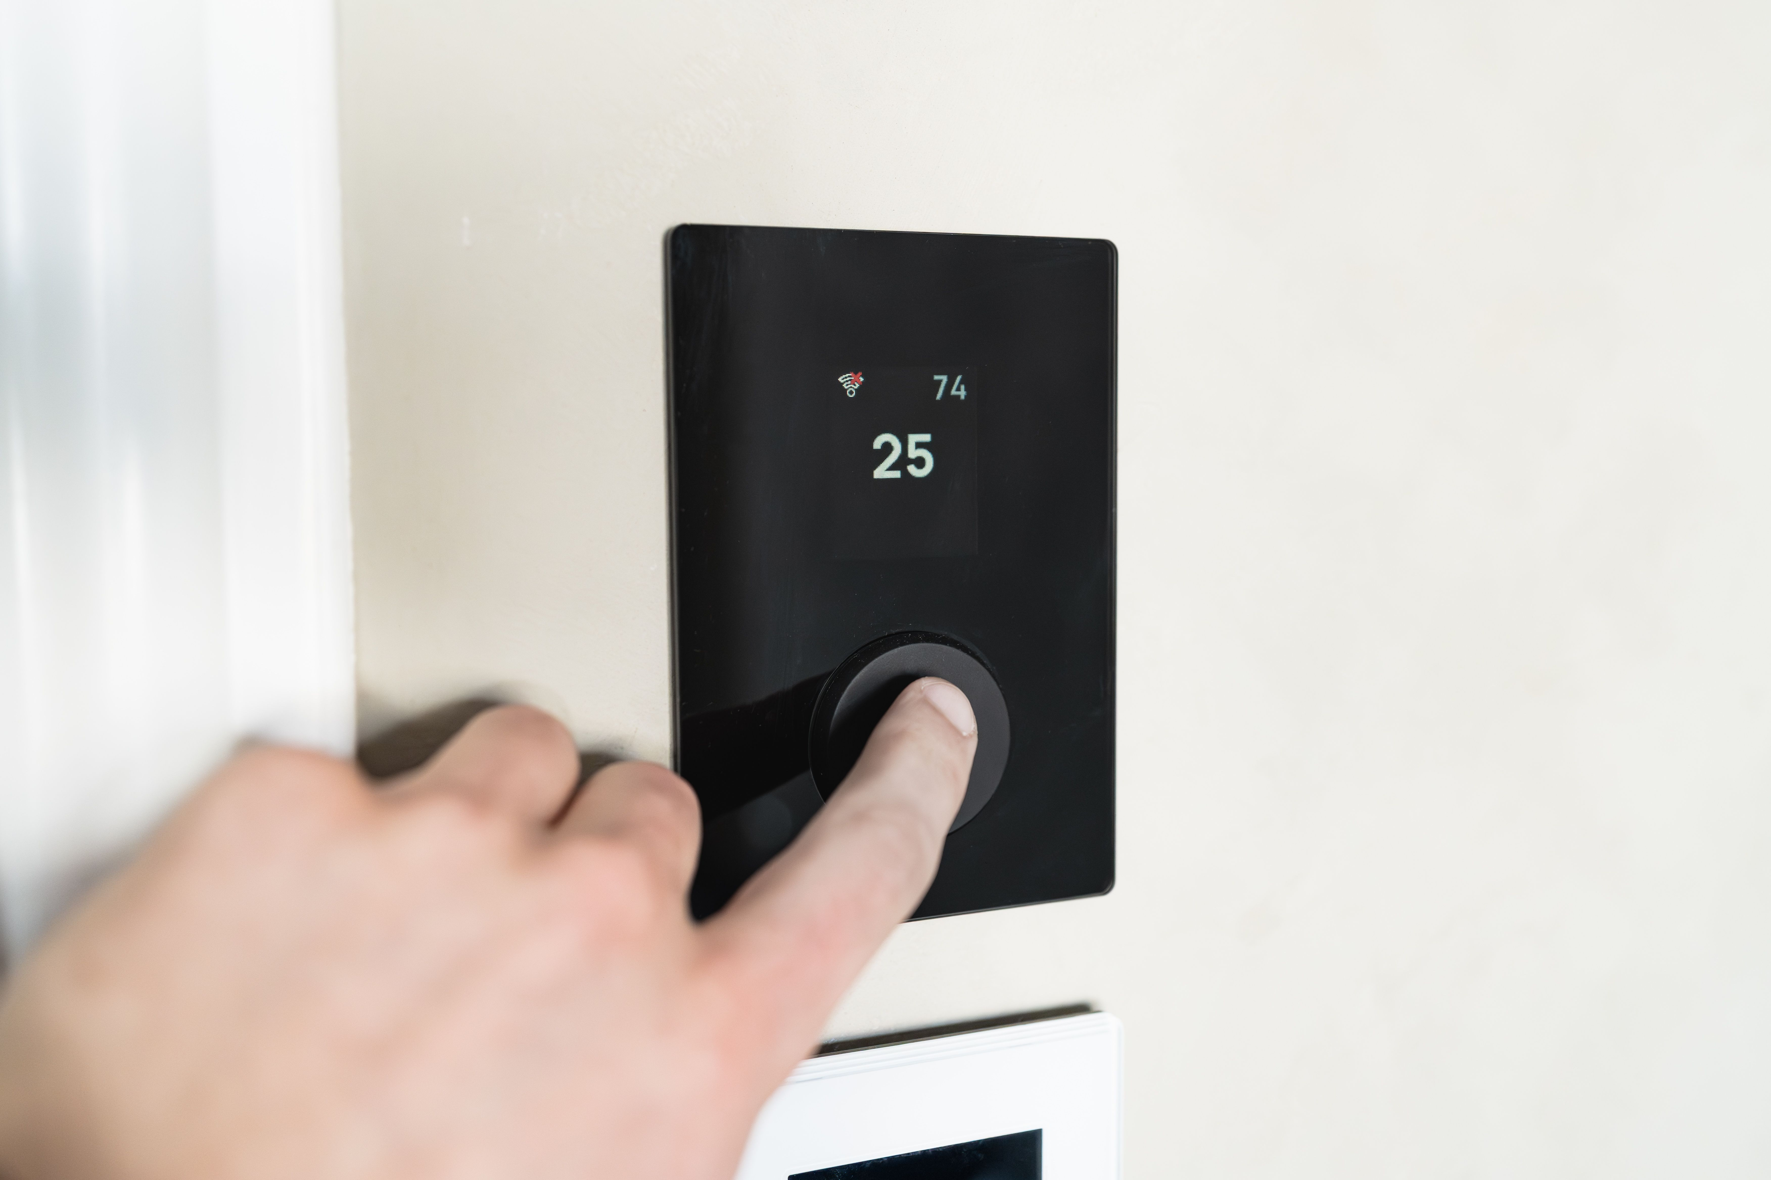
Slide 6 (Fix) - a hand presses the single black dial on a sleek wall mounted smart thermostat, display reads 25 / 74, small wifi icon lit, plain wall behind. Gate0: viewed direct, 7008x4672px, URL verified, not a banned trope, used once, Pexels License traced. Scores: subject match (metaphor for set it once) 9, five unrelated posts test 8, charge 7, currency 9, legibility 9, set distinction 9.: https://images.pexels.com/photos/36818203/pexels-photo-36818203.jpeg
Source: https://www.pexels.com/photo/modern-smart-thermostat-with-user-interface-36818203/ Author: HUUM License: Pexels License (free for commercial and non commercial use)
Slide 7 (CTA, save and share) - reuse of Slide 3's clock photo, cropped up into just the softer reflected duplicate of the digits on the dark ceiling, no clock body visible, a visibly different composition from Slide 3. Gate0: reuse permitted (2 of 2 max), same Pexels License traced. Scores: subject match (metaphor) 8, five unrelated posts test 7, charge 7, currency 9, legibility 10.: https://images.pexels.com/photos/30223389/pexels-photo-30223389.jpeg
Source: https://www.pexels.com/photo/digital-clock-at-7-00-reflecting-in-a-modern-building-30223389/ Author: Tanay Agrawal License: Pexels License (free for commercial and non commercial use)

Visual Direction (for the design step)
Hero image: Extreme close up: a finger hovers just above a smartphone screen lit in a vivid magenta to cyan gradient. Dark and saturated negative space top right and bottom left carries the headline and open loop subhead.
Alt image queries: finger tapping pause icon phone screen dramatic light | glowing digital clock dark abandoned room | car dashboard warning lights red needle close up
Color mood: teal accent energy (Growth Marketing pillar), duotone grade over each photo's own real color; the neon magenta and cyan of the hero sets the accent temperature carried through the rest of the set
Symbol corner: top-right
Logo (CTA slide): full white Rarity logo on dark background (CTA slide, dark ceiling crop)

Rights / Sensitivity
All five source photographs are published on Pexels under the Pexels License (free for commercial and non commercial use, attribution not legally required though photographers are credited anyway as good practice): Jakub Zerdzicki, Tanay Agrawal, Lukasz Pajzert, Luke Miller, and HUUM. No real, identifiable people appear in any frame (hands, a dashboard, a thermostat and a clock only), so there is no editorial personality clearance concern. Verification of every image was done by downloading each file and visually viewing it directly (not from a search thumbnail or alt text) and by fetching each Pexels source page directly for photographer credit and license terms, since this environment has no interactive Chrome browser. The only claimed number, the 75 percent overspend figure, is quoted directly from Meta's own Business Help Center and must not be rounded up, combined with the older 25 percent figure, or otherwise dramatized beyond what Meta currently states.
Next step: run rarity-ig-designer on this brief to build the EN, ES, and PT art with rarity-ig-designer.

